# Calculate and Plot Two EMAs using TA-Lib

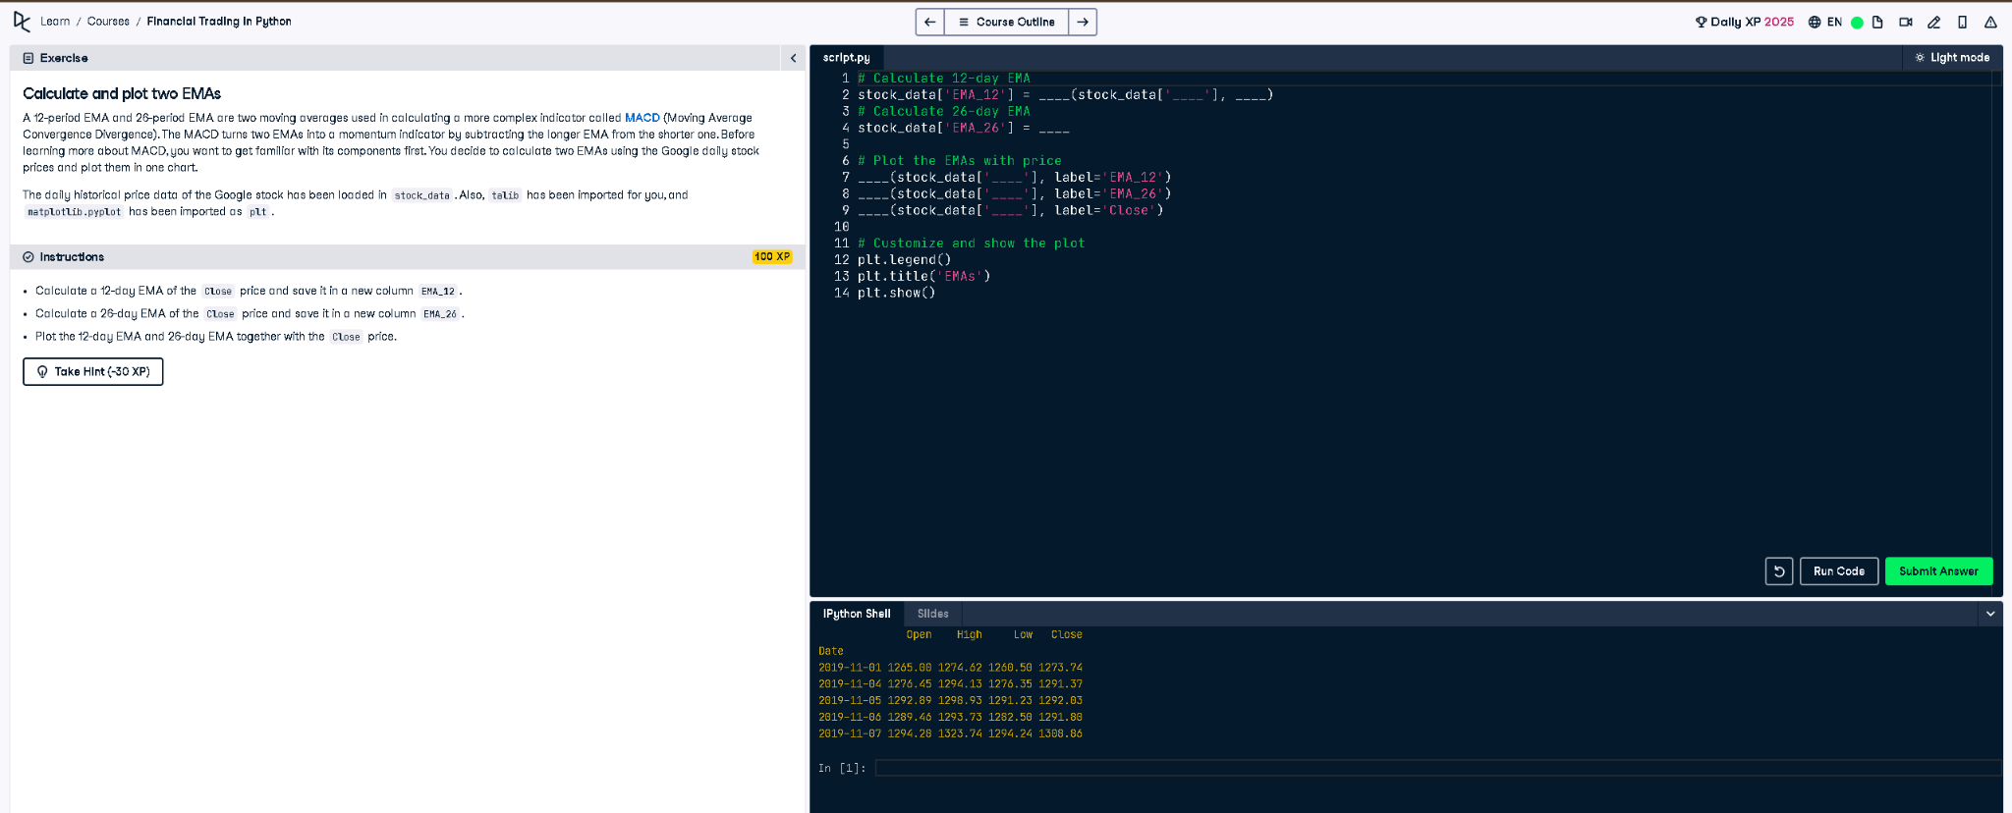

## Python Code

# Calculate 12-day EMA using talib  
stock_data['EMA_12'] = talib.EMA(stock_data['Close'], timeperiod=12)  
  
# Calculate 26-day EMA using talib  
stock_data['EMA_26'] = talib.EMA(stock_data['Close'], timeperiod=26)  
  
# Plot the EMAs with price  
plt.plot(stock_data['EMA_12'], label='EMA_12')  
plt.plot(stock_data['EMA_26'], label='EMA_26')  
plt.plot(stock_data['Close'], label='Close')  
  
# Customize and show the plot  
plt.legend()  
plt.title('EMAs')  
plt.show()

## Explanation

This script calculates two Exponential Moving Averages (EMAs) using the talib library. The 12-day and 26-day EMAs are computed from the 'Close' price column of Google stock data. Then, it plots both EMAs along with the original closing prices to visualize the trend.